DSF
DEPARTMENT OF PHARMACEUTICAL AND PHARMACOLOGICAL SCIENCES

Technical Services and Scientific Equipment

MacIn Facility
Macromolecular Interactions Facility

Description and application fields
The Macromolecular Interactions Facility (MacIn Facility) is a key research service of the University of Padua, housed in the Pharmaceutical and Pharmacological Sciences Department (DSF).
The research facility allows the biophysical characterization and the macromolecular interactions of peptides, proteins, oligomers (DNA and RNA) and other macromolecular systems, that are currently being investigated as drug delivery vehicles (micelles, vesicles, liposomes, polymersomes, nanoparticles and so on). It provides a wide range of instruments and resources for biophysical characterization (size, shape, and surface charge analyses), for complex formation, for substrate affinity and for thermal stability of many different macromolecular systems. Core instrumentations include: a spectrofluorometer; a circular dichroism spectropolarimeter; surface plasmon resonance (SPR)-based biosensors; a microfluidic device to produce narrow-disperse lipid formulations; two dynamic light scattering instruments; differential scanning and isothermal titration calorimeters; and a fluorescence microplate reader.
A staff of senior technical experts will provide training courses for students and researchers, and it will support academic collaborations and biotech commercial services.

Facility staff and contacts: Sara Bersani, Ph.D. (manager) sara.bersani@unipd.it
Phone number: (+39) 049 827 5360
from Monday to Friday 9:00 a.m. - 5:00 p.m.
Scientific board and research supervisors: Prof. Gianfranco Pasut gianfranco.pasut@unipd.it

Training courses
Specific training courses for researchers will be held by the staff, to make them independent in sample preparations and data acquisition processes.

How to book
All the researchers can book using the online system and log in with accredited credentials that will be generated after the training course (http://147.162.61.199/).

Location Pharmaceutical and Pharmacological Sciences Department
Via Marzolo, 5 - 35131 Padova - Italy
All the instruments of this Facility are placed in the B Building Block, as reported below in the map [Geotec: 00240 00 0018-019-020].

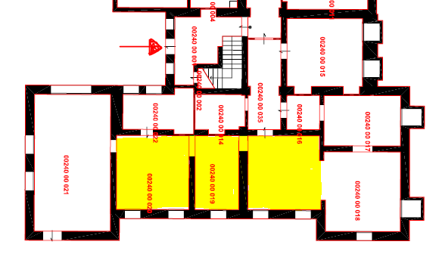

Equipment

Jasco J810: Circular dichroism (CD) spectroscopy has a wide range of applications in many different fields. Most notably, UV CD is a very useful technique to study the secondary structure of a large variety of biological chiral molecules and how their conformation changes using different environment, temperature or pH conditions or interacting with other molecules.
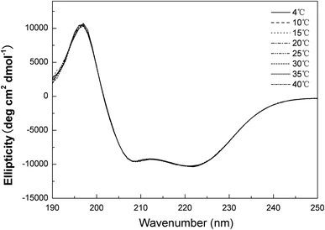

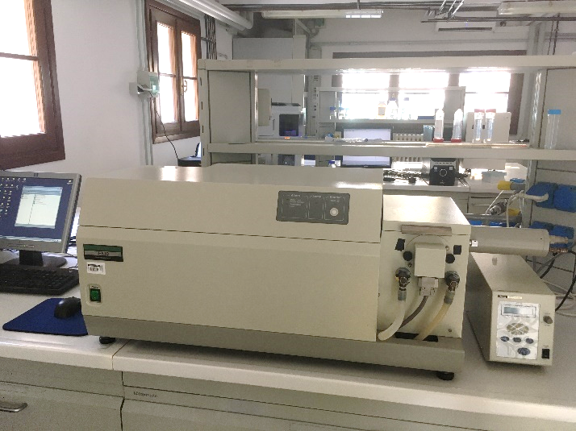

Jasco FP6500: This instrument can be used to measure the intrinsic fluorescence of a large variety of compound in solution, namely small drug molecules or peptides and protein or RNA/DNA. The range of the spectrum goes from 190 nm to 900 nm. The presence of a Peltier system allows to thermostat all the measurements or to create ad hoc temperature ramps for the analyses.
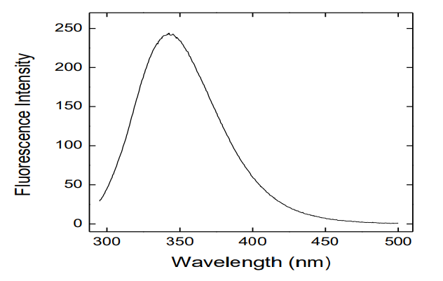

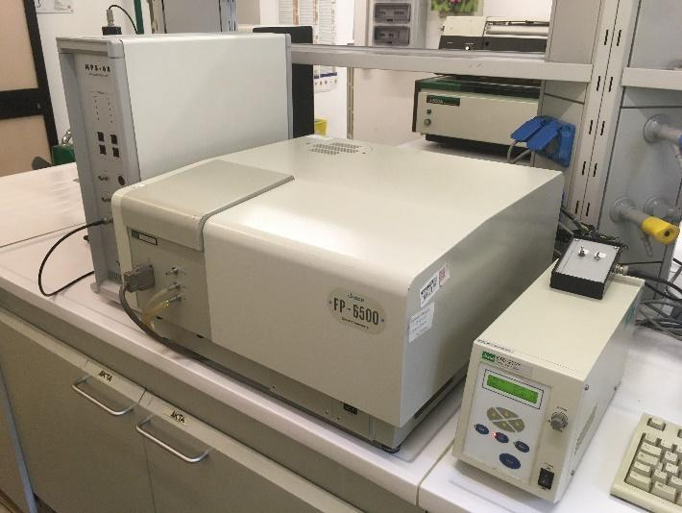

GE/Cytiva Biacore X100: The Biacore X100 is a versatile and flexible instrument which allows to study the interactions between any type of molecule (in principle), from organic compounds to proteins, nucleic acids, glycoproteins and even viruses and whole cells, in any type of mixture. Surface plasmons change their resonance wavelength according to the type of interaction between the molecules flowing on a suitably functionalized gold surface. The obtained sensorgram provides quantitative data on the binding processes, kinetic constants, specificity/affinity characteristics.
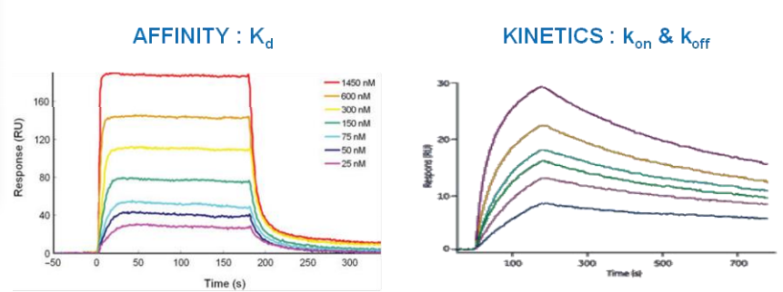

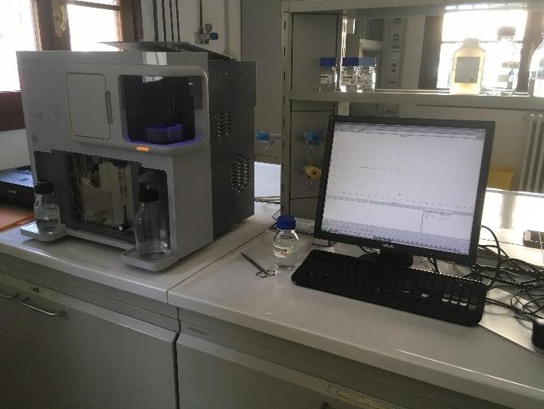

Precision Nanosystem NanoAssemblr®BT: The NanoAssemblr®BT is an innovative system that, through a continuous and controlled flow pumping system, exploits the microfluidics contained in a cartridge for the rapid production of soluble nanosystems and monodisperse colloids. A very intuitive and easy-to-use software allows, through the control of a few parameters, such as Total Flow Rate (TFR) and Flow Rate Ratio (FRR), to adjust the flow of solutions to obtain particles with precise dimensions and with an encapsulation efficiency that can be reproduced over time. Volumes from 1 to 15 mL can be processed.

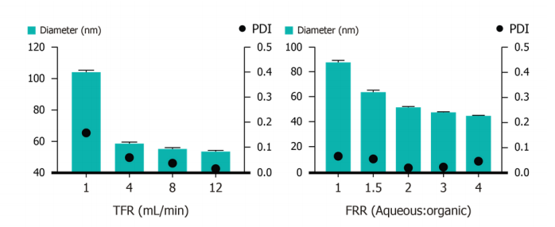

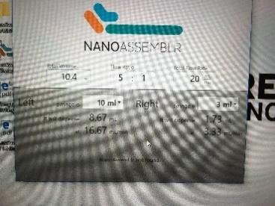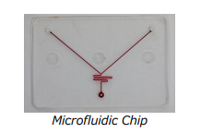

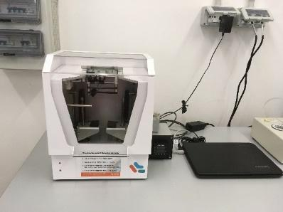

Malvern Nano ZS (location: 00190 -1 057) and Ultra ZS: Nano ZS and Ultra ZS are indispensable tools for those who work with soluble nanosystems. These instruments, by exploiting the Dynamic and Electrophoretic Light Scattering (DLS and ELS) phenomena, allow to determine the size, electrophoretic mobility, and surface charge of soluble and/or suspended nanosystems in solution, such as colloidal systems, proteins and nanoparticles. The measure range is between 2 and 1000 nm. They are tools of choice for the publication of dimensional data in the scientific publications of the Drug Delivery field.

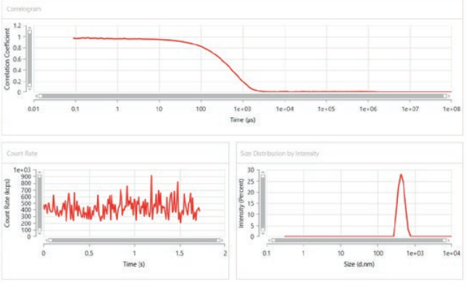

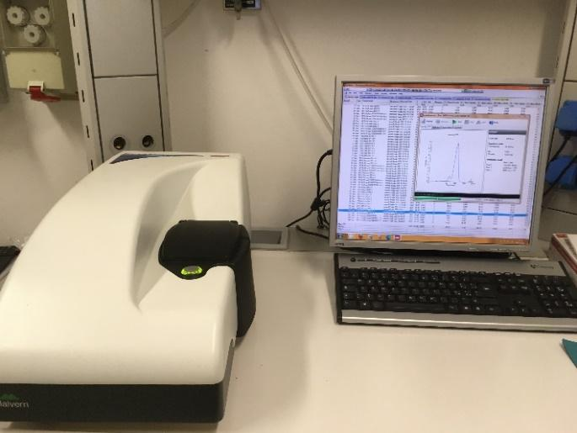
Nano ZS
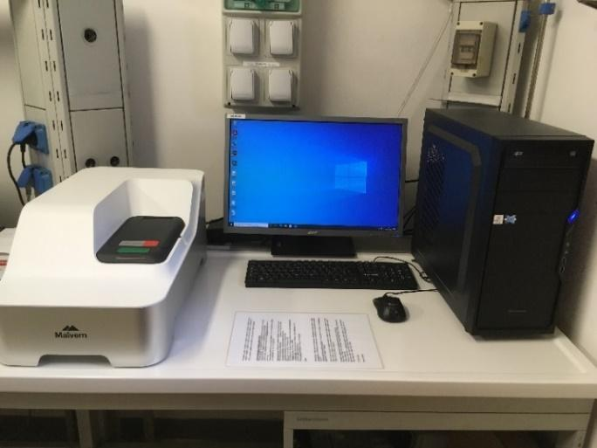
Ultra ZS

Malvern MicroCal VP-ITC: The MicroCal VP-ITC is a powerful and sensitive, easy to use, isothermal calorimeter that allows you to perform calorimetric titrations in a precise and accurate way. It offers the possibility to study and measure the molecular interactions between peptides, proteins, antibodies, nucleic acids and many other biomolecules, defining the binding/unbinding constants of the experimental model.
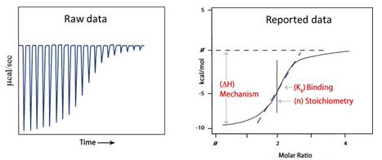

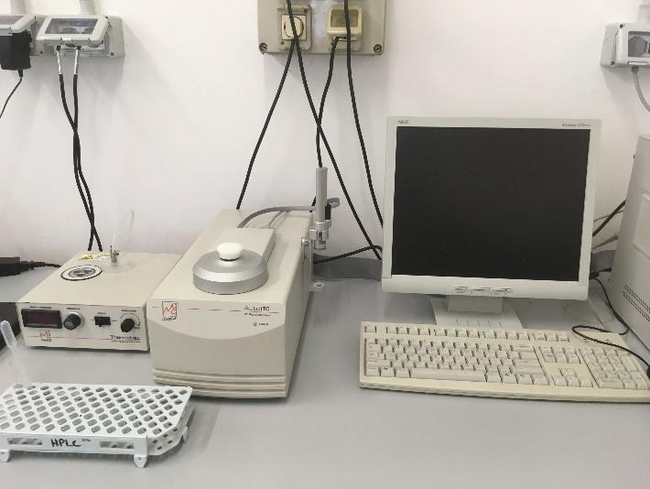

Malvern MicroCal VP-DSC: Differential Scanning Calorimetry (DSC) is a powerful analytical tool to characterize the stability of proteins and other biomolecules. The VP-DSC microcalorimeter directly measures the enthalpy (ΔH) and the thermal transition temperature (Tm, transition midpoint) of structural transitions of biomolecules in solution and provides a "fingerprint" that can be used to characterize and evaluate their structural conformation, such as hydrophobic interactions, hydrogen bonds, conformational entropy, and chemical surroundings. These analyses are very lengthy, but they provide a complete thermodynamic profile of protein folding/unfolding process without labeling or the use of artificial probes, so molecules are studied in their native states.

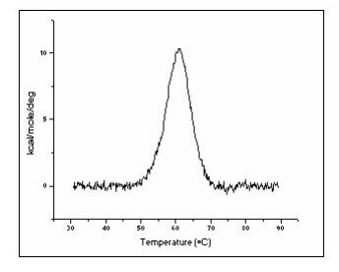

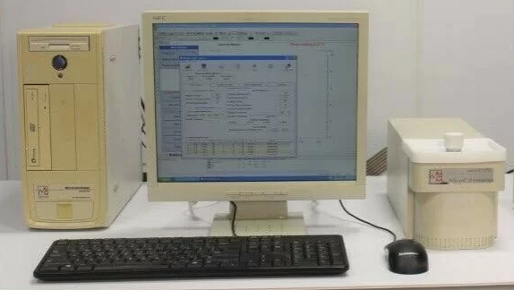

Perkin Ellmer Victor NIVO: The Victor Nivo MultiMode microplate reader is a simple and versatile compact instrument. It detects in five different modalities: absorbance, luminescence, fluorescence intensity, fluorescence polarization and time-resolved fluorescence. It allows to work using expanded temperature control up to +50 °C.
It includes different filters, 355/40 nm, 405/10 nm, 430/30 nm, 530/30 nm, 700 IR Blocker, Unfiltered (00240 building) and 355 nm - 405/10 nm - 440 nm - 460/30 nm - 510/30 nm - 510/60 nm - 530/30 nm - 570/10 nm - 630 nm - 750 nm (00200 building), but others can be added to perform featured measures. 6-well to 384-well microplate formats can be used for the analyses.

