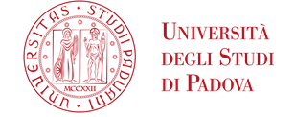

Survival Guide
for
International Students
International Desks @ Unipd

Index
Index 2
Welcome! 4
Must-know 5
Getting ready for your journey at the University of Padua 6
Stay permit and accomodations 8
Start your journey at the University of Padua 9
The Academic Calendar: classes periods and exam sessions 9
Web Agenda: classes, timetables, exams calendar and classrooms 10
Where to find the lectures: building facilities 14
Online student services 16
Funding and fees 19
Par-time job opportunities 20
Plan your Studies:
credits, study plan and exams 21
ECTS 21
Study plan 22
How to fill in the study plan 23
Exams and grades 25
Study support 27
During your Studies 29
Services and free time 29
Change University (transfer), degree programme, study track 33
International mobility opportunities 34
Internship 36
Obtaining your degree 37
Writing your Thesis 37
Registering for graduation 39
After your studies 40
Contacts 43

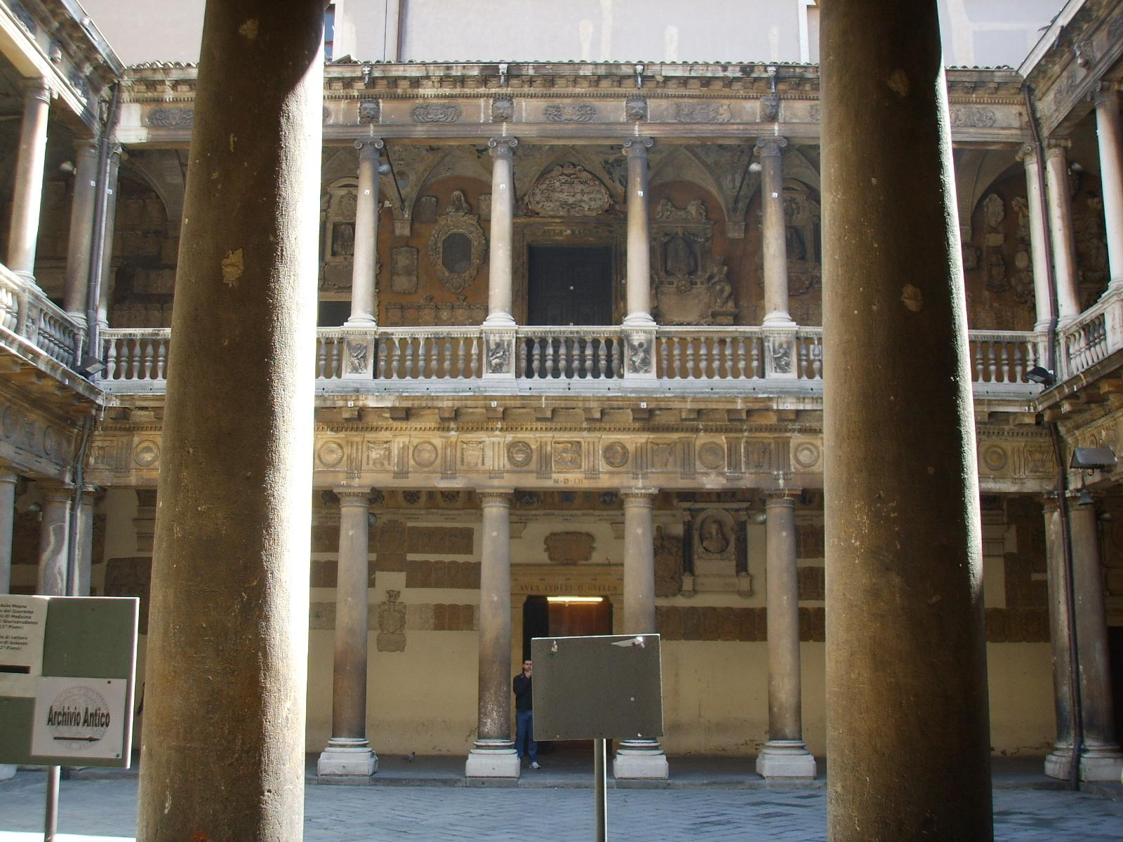
Palazzo Bo

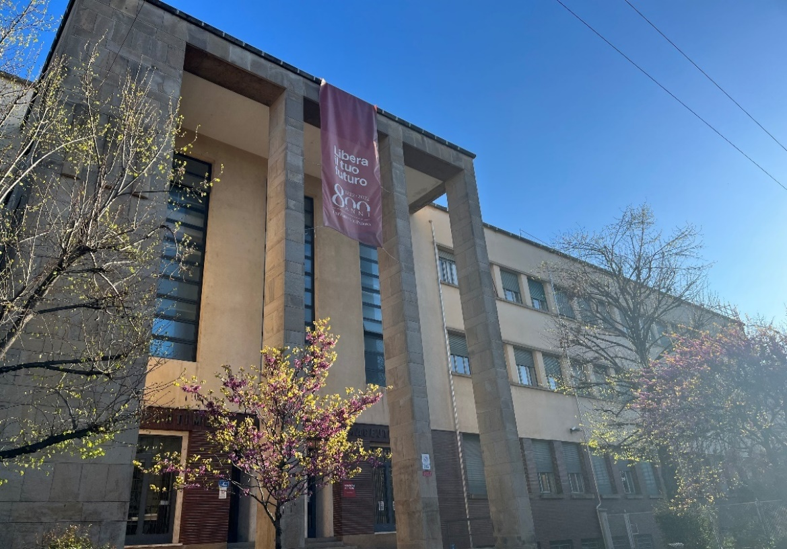
Department of Pharmaceutical and Pharmacological Sciences (DSF)

Welcome!
- - - - -
Dear student,
Welcome to the University of Padua! We hope you are as excited as we are for the start of the new academic year. We also know how challenging beginnings can be: for this reason, we would like to help you to get your head around the University and the city.

As International Desks, we have designed a survival guide to support your first steps once you have arrived in Padua as well as to clarify any further doubt eventually arising during your student’s career journey. Here you will find important information about your studies, useful contacts and some tips for a successful student career and a unique experience in Padua.
Must-know

Ciao!
Buongiorno
Come stai?
Piacere di conoscerti
Come ti chiami?
Arrivederci
Grazie
Prego
Per favore
Scusa
Non capisco
Aula
Lezione
Dove sono le lezioni?
A che ora iniziano le lezioni?
Spritz
Vorrei uno spritz, per favore
Goto
Un’ ombra de vin
Hi! Hello!
Good Morning
How are you?
Nice to meet you
What’s your name?
Goodbye
Thank you
You’re welcome
Please
Sorry/Excuse me
I don’t understand
Classroom
Class
Where are the classes taking place?
What time do the classes start?
Spritz, typical alcoholic beverage
I’d like a spritz, please
Glass (in the dialect of Veneto Region)
A glass of wine

Getting ready for your journey at the University of Padua

If you are wondering how you can apply to the Master’s Degree programme in Pharmaceutical Biotechnologies…do not worry, you are in the right place!

Both your citizenship and where you got your entry title will affect your application process.
- Check here the category you most identify with and find out how to apply!

- Am I an international student?
You are considered an “international student” if you hold a non-Italian academic diploma, degree or equivalent.

- Are international students eligible for admission?
Of course. Please note that candidates need to apply through different platforms according to their entry qualification. This information is specified in the Call for Admission.

- When and where can I find information on how to apply?
This information is specified in the Call for Admission. The Call for Admission contains all the necessary information regarding the application procedure, entry requirements, deadlines, number of places available and quota for non

EU citizens residing abroad. Each Call for admission refers to specific applicants categories (EU/EU-equated or non-EU citizens, Italian or foreign entry qualification holders) which may not include you therefore you have to read them thoroughly.

Further doubts? Check our F.A.Q.

Stay permit and accomodations
- - - - — - - - - - -
The University of Padova supports international students in different phases before and during their arrival in Padova.
For any guidance through the process of obtaining your Italian stay permit, you can contact the SAOS office. SAOS is a welcome desk which assists incoming international students and scholars (researchers, visiting professors, experts) in organizing and completing the most important procedures related to their legal stay in Italy:
Otherwise, you can follow the step-by-step guide or the online tutorial.
Email: saos@unipd.it

For information on accommodations in Padua, you can check our website here.
Email: housing@unipd.it

Start your journey at the University of Padua

The Academic Calendar: classes periods and exam sessions
- - - - — - - - - - -

Every year the activities of the University of Padua are marked by the Academic Calendar, which contains the deadlines and holidays of the University. The academic year begins on October 1 and ends on September 30, and usually comprises two semesters. The beginning of the academic year does not necessarily concise with the effective beginning of the academic activities.

Typically, the Academic year is divided as follows:
FIRST SEMESTER:
- Classes from end of September to January
- Winter exam session from January to February
SECOND SEMESTER:
- Classes from end of February to June
- Summer exam session from June to July
Extra exam session: August - September
NB: Classes are suspended during Christmas holidays, Easter holidays and Summer holidays. Check out key academic dates here.

Web Agenda: classes, timetables, exams calendar and classrooms
- - - - — - - - - - -
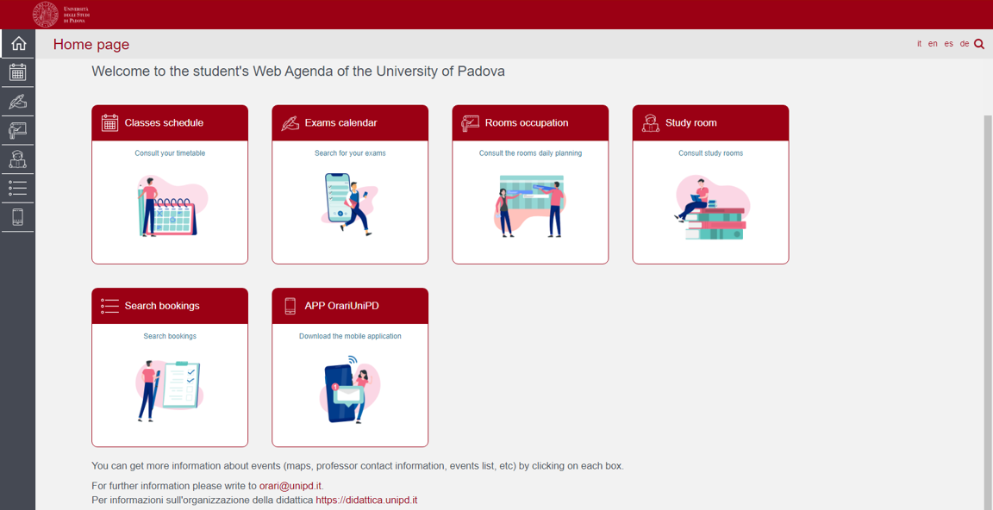
An important tool during your studies at the University of Padua is the student’s Web Agenda.

Once on the homepage, you will be able to get more information about the events (maps, teacher contact information, list of events, etc.) by clicking on each section.
Get now to student’s Web Agenda:

Classes schedule:
Search you timetable by degree, lecturer or teaching unit.
For example:
- Select the Academic year
- Select the School School of Medicine (Scuola di Medicina e Chirurgia)
- Select the Course of study ME 2193 – Pharmaceutical Biotechnologies – Biotecnologie farmaceutiche
- Select the year of study and precise week you want to find
Then click on View Timetable
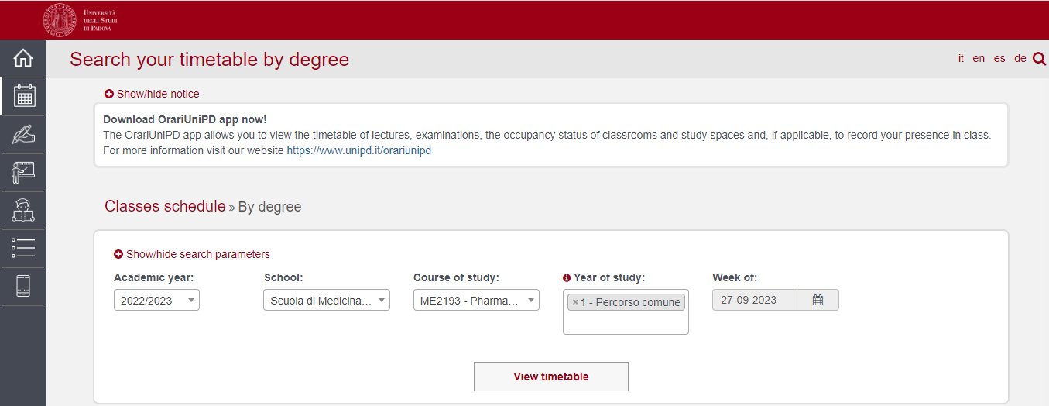

For a more practical view just go down through the page, click on the bottom "Full calendar". Then, by clicking on "Export Excel", you will be able to have the full list as an excel sheet. For each course you will find reported the name of the course, teachers of reference, location, methods of development, and schedules.
It is important not to miss lessons!

Attendance is compulsory for a minimum of 75% of classroom hours and for 100% of laboratory practice – See art.7 par. 1 of the Degree programme regulations

Exam calendar:
Find the exams by degree, lecturer or teaching unit. Select your School, your degree programme and the year of study.

Rooms occupation:
Select a date and a site of the University to see which rooms are occupied by which classes or activities. Do not forget to have a look at the colour legend at the bottom of the website page
Study rooms:
Select a study room and verify the capacity, location, availability and opening times.

Search bookings:
Check the rooms’ bookings in order to find out where and at what time a class, event or meeting is held. Also, by clicking on the name of the room you can easily find its exact location on the map.

Apps:
We invite you to download the App OrariUnipd to keep all information monitored directly from your smartphone. You will always have access to your lesson timetable, the exams calendar and the classrooms of all the university daily occupation, in addition to other functionalities that your university gives to you.
You will also receive push notifications that teachers and secretariats will send to inform you about last-minute class changes, invitation to events, seminars, lecture suspensions, and so on.
Do not forget to have a look at all the useful apps offered by the University of Padua!
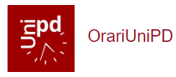

Where to find the lectures: building facilities
- - - - — - - - - - -

The Master’s degree course in Pharmaceutical Biotechnologies is under the Department of Pharmaceutical and Pharmacological Sciences - Dsf and is managed by the School of Medicine.

Department of Pharmaceutical and Pharmacological Sciences – Dsf,
Via Marzolo 5, Padova

https://www.dsfarm.unipd.it/
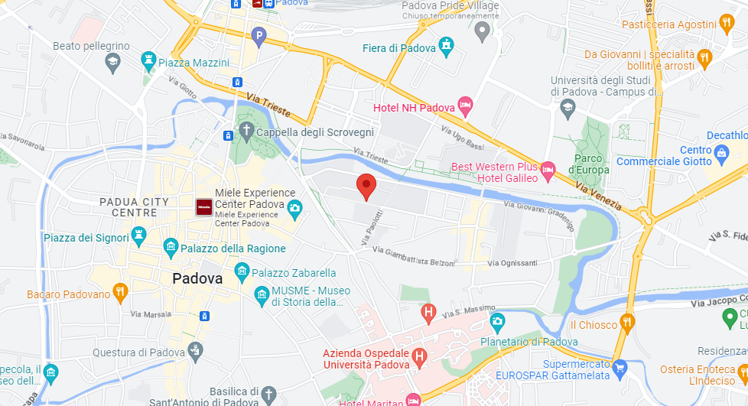
Check here the main Departmental Buildings

Located in the city centre:
- 1,3 km from the train station
- 1,2 km from the main city’s square, Piazza dei Signori
- 1,9 km from Prato della Valle

Classes are held in the following buildings, depending on the Degree course’s year you are attending.

Click on the location to open Google Maps.
Edificio di scienze farmaceutiche – Aula 2
Edificio di farmacologia – Aula Zancan
Edificio di farmacologia – Aula Meneghetti
Complesso didattico di biomedicina Fiore di Botta – Laboratory
Laboratory of Biochemistry and Biotechnology

Please be aware that before accessing a laboratory, you must prove that you have attended the relevant safety course. Once you have completed this course, you will obtain a certificate demonstrating your attendance.

The following trainings are required:
General Training (4 hours)
Specific training High Risk (12 hours)
Do not forget to check on the App OrariUnipd the time, the class and the room!

Online student services
- - - - — - - - - - -

Here you can find a short list of the platforms, applications, softwares and other tools that can be useful during your studies:
Unipd Webmail: the institutional mailbox students will be given once enrolled in a degree programme at the University of Padua (i.e., name.surname@studenti.unipd.it). Username and password are the same to log in to Uniweb.
The institutional Unipd account is a fundamental tool during your academic studies: the University will communicate with you through the Unipd account, so we recommend you to check it regularly so that you don’t miss any important information!
Uniweb: the information system of the University of Padua which allows students to access the information about their university career, from pre-registration and enrolment procedures to exam enrolments and degree applications. Also, professors use Uniweb to insert exam calls, publish exam grades and register exams.
didattica.unipd: the educational offer of the University of Padua filtered by Schools and degree programmes. Once on the page of your degree programme, you can find information about the regulations of your degree under the banner ‘Degree course details’. Make sure you read them carefully! You can also find information about each teaching unit and office hours of your professors. Pay attention in selecting the educational offer related to the correct academic year.

Moodle: a free software e-learning platform which functions as an online support to traditional classes. Moodle allows teachers to create online lesson resources for students, to communicate and post information on course units and lessons, and to create assignments, exercises, and tests. In the homepage, you will usually find the list of participants (including the teacher and students) and a calendar with a course schedule and list of assignments. Other Moodle features include online quizzes, forums, where students can post comments and ask questions, glossaries of terms, and links to other online resources. As Moodle is a web-based application, students can log in any time from home or elsewhere. To log in, students will be asked to use their Unipd email account (name.surname@studenti.unipd.it) and to complete the procedure, they will be given a password to enter.

Zoom: a video conferencing platform for online classes you can download or access with the University Single-Sign-On authentication (@studenti.unipd.it)

Eduroam: an open network for students and staff members of the University of Padua as well as to guests coming from other institutions participating in the education roaming. Find out more information here.
MyUnipd: a quick and easy way to manage your university career from your smartphone or tablet. Check out all the other useful apps for your studies and your stay in Padua!

Funding and fees
- - - - — - - - - - -
Payment of tuition fees gives access to all services provided by the University of Padua. The maximum fee depends on the programme, but it does not exceed 3,000 euros per year and it is divided into 3 instalments.
Here you will find the fee structure for students enrolled starting from the Academic year 2023/2024.
As the University of Padua offers several degree-seekers scholarships, we invite you to explore the relevant webpage to have a look at the merit-based and income-based scholarships offered by the University of Padua, Veneto Region and other public and private institutions.
For further information about fees, scholarships and awards, you can find out more here: Funding and Fees | Università di Padova
Further Contacts:
benefici.studenti@unipd.it

Part-time job opportunities:
- - - - — - - - - - -

As an international student in Italy, you are free to take a part-time job in order to help cover your costs. Non-European students need to have a valid residence permit and, according to Italian Law, are allowed to work up to 20 hours/week.
You could look for both “in campus” or “off-campus” job opportunities!
“In campus” job opportunities are part-time job opportunities offered by our University and regulated by specific calls:

- Student collaborations (200 hours)
- Tutoring

Find out more information here.

Plan your Studies:
credits, study plan and exams
Whether you are starting your Bachelor’s degree or you are enrolled for your Master’s degree, in the following section we have prepared for you some useful information to start your new academic experience at the University of Padua.

ECTS
- - - - — - - - - - -
The European Credit Transfer and Accumulation System (ECTS) introduces the “credit” as the unit of measurement which defines the student workload, including time spent attending lectures, seminars, independent study, and examinations. Each course unit is assigned a certain number of credits which students obtain by passing exams and/or other assessment tests.

Key elements to keep in mind:
- 1 ECTS credit = 1 Italian CFU (Crediti Formativi Universitari)
- Each exam/activity corresponds to a certain number of credits (ECTS/CFU)
- 1 ECTS credit = 25 working hours
- 2nd cycle/Master’s Degree (2 year Programme) = 120 ECTS
- CFU are distributed among semesters: a total amount of 120 CFU is needed for graduation in the Master’s degree programme in Pharmaceutical Biotechnologies

Study plan
- - - - — - - - - - -

General information
Once you are settled in Padua and the academic year has started, you must fill in a Study Plan.
The study plan is the complete list of exams students must carry out in order to earn the credits (CFU/ECTS) required to graduate. Each degree programme includes a number of learning activities such as teaching units, workshops or other activities. Some of them are compulsory, others are optional (you can choose among a group of courses) or electives (free choice).
Degree programmes can be organized in a single or multiple curricula, and these are specified in the relevant ‘Outline for a Study Plan’ (Manifesto degli Studi).
The sum of the compulsory and optional activities represents your study plan. Students must fill out and submit the study plan according to the ‘Outline for a Study Plan’ (Manifesto) of their degree programme and to the rules related with their enrollment year.

Pharmaceutical Biotechnologies Master’s Degree programme – specifics
- It is structured as a single curriculum / common track
- Check the Master’s Degree regulations for further information
- Download Annex 2 of the Master’s Degree regulations and verify the study progression and proposed educational activities related to your cohort

How to fill in the study plan
- - - - — - - - - - -

General information
To fill in and submit the study plan login to Uniweb with your Unipd email credentials (name.surname@studenti.unipd.it).
Students must fill out the study plan every year and for the whole duration of the Degree programme in which they are enrolled.
There are two types of study plans:
Automatically approved: it allows you to choose your elective course units only among the educational activities offered by your Department/School in order to fulfil credit requirements. It is approved as soon as you click on 'Confirm Plan' (i.e. all the activities are immediately uploaded to your online Transcript) | Requiring approval: it gives you the possibility to include educational activities offered by other Departments/Schools but is subject to approval by the relevant Degree Programme Board (CCS - Consiglio del Corso di Studi).
Do not worry! You can change your study plan throughout the year according to the specific submission periods until you register for graduation. The specific deadlines are set by the relevant School or Department.
The submission of the study plan is compulsory. Please be aware that you cannot take an exam if you have not submitted your study plan and/or it has not been approved yet.

For the specific rules of your degree programme, we invite you to read the relevant Regulations.
Make sure that the elective courses you choose are compatible with your degree programme. Please check if further restrictions are specified in the ‘Outline for a Study Plan’ (Manifesto) of your Degree Programme and the submission periods of your School. Once you have submitted your study plan, we invite you to check whether it has been loaded in your online track before exam sessions start.

Pharmaceutical Biotechnologies Master’s Degree programme – specifics
- Check the Pharmaceutical Biotechnologies study plan deadlines here
- Students can choose elective courses outside the School of Medicine, but they must be coherent with the overall study plan and duly approved by the relevant Degree Programme Board.
- Should you have any doubts related to your study plan, you can contact the Administrative Secretary of the relevant Department.

Exams and grades
- - - - — - - - - - -

Exams are designed to test the knowledge and skills you acquired with a specific course unit. Each training course includes a final examination to be done at the end of the period in which the course takes place. In case of training courses divided into modules, a joint and single final grade is provided. Only the passing the final assessment enables the student to acquire the CFUs attributed to the training activity in question.
- See art. 4.1 of the Degree programme regulations

Key facts:
- Types of exams: exams can be either written (multiple-choice questions, open questions, exercises) or oral, or both (in this case the exam is divided into multiple parts). Exams can be written or oral report on the activity carried out; an open-ended question test or a multiple-choice test; a lab test or computer-based practical work; a practical test or a project. Before the start of each academic year, the university teacher in charge of the course unit will publish information on how the final examination is structured - which may include one or more of the types listed above - the assessment criteria and the possibility of carrying out mid-course tests. In this case, the so-called partial exams are exams whose grade is recorded later in the booklet, in an official exam session. It is only the final examination that appears in the online booklet, once the entire exam has been successfully passed and recorded by the professor in charge.
- See art. 4.3 of the Degree programme regulations

- Exam Session: Period of time during which lectures and educational activities stop and students can take the exams according to their Degree Course. There are three exam sessions during every year: one in Winter, one in Summer and one in September.
- Scores: Italian Universities use a 30-point scale for exams where the minimum passing grade is 18/30 and the maximum is 30 e lode (30/30 cum laude).
- Signing up: to sit an exam you will have to sign up for it. Check the instructions on how to register for exams.
- Results: in the section ‘Exams Results’ of your Uniweb page you will find the results of your exams. We invite you to read carefully the Regulations of your degree programme for further information concerning rules and modality for academic examinations.
- Reject or accept: If you are not satisfied with your exam result, you have the possibility to reject it within 7 days after its publication on Uniweb, or it will be permanently recorded in your Transcript of Records. Please note that grades below 18/30 are not recorded in any case. Please be aware that once you refuse the grade, you will not be able to reclaim it afterwards. Here you can find the instruction for grade refusal.

If you reject the grade or fail an exam, you can retake it in another session, but do not forget to sign up for it! Remember that only the last obtained result will be considered, and not the best one!

Study support
- - - - — - - - - - -
As you start your new academic experience, we want to make sure you have all the information you need about the study support offered by the University of Padua.

Tutors:  The Tutoring Service supports students throughout their University career. Tutors help students to manage their study time and to deal with any organisational difficulties, such as completing study plans, and offer support to plan for examinations.  Tutors are students enrolled in single-cycle degrees, Master's degrees, doctoral degrees or specialisation degrees.  Student Service Office - Guidance and Tutoring: tutorato@unipd.it  Tutoring service of the Master’s degree programme in Pharmaceutical Biotechnologies: | Buddy:  International students can be assisted by a Buddy (i.e., a Master's degree student), who will welcome and support them during their stay in Padua.  Buddies are usually assigned to a group of international students and help them to deal with administrative procedures and to get their head around university life by answering their questions, accompany them to the University offices in case of need, and, at the same time, help them to integrate into university life.

- Visit the dedicated webpage
- Email to: riccardo.cavarzeran@studenti.unipd.it

Professors:  Let us remind you that you can meet with your professors and teaching assistants during office hours. These are hours scheduled outside of class to meet with students for questions about the material being presented in class or other related interests students have. On the syllabus, which you can find on didattica.unipd, each professor publishes the schedule and the modality of the office hours. | SLD:  Students with disabilities or Specific Learning Disabilities (SLD) have access to specific tools and services supplied by the University of Padua during their studies. Students with a disability can also benefit from special scholarships and fee-waivers, based on family income, merit and disability level.  Student Service Office - Inclusion: inclusione.studenti@unipd.it

During your Studies

Services and free time
- - - - — - - - - - -
Once you have planned your studies, you can start exploring the services the University offers and the life in the city of Padua. As a student of the University of Padua you have access to a wide range of services and facilities - make sure you check them out!
Physical and digital libraries: the University provides its students and staff with a University Library System, which includes a vast bibliographic and informative heritage accessible from both university libraries and through a digital library. To discover all services related, please check the dedicated webpage. In addition to the resources normally available in open access, the University of Padova also provides contents and tools usually accessible only under subscription. Most of the resources can be consulted off-campus using the Auth-Proxy service or the University Single-Sign-On authentication.

Libraries of special interest for Pharmaceutical Biotechnologies students:
- Biblioteca di Science del Farmaco
- Centro di Ateneo per la storia della Scienza – sezione documentale

Study and computer rooms: the University offers various study rooms with different capacities to all students, as well as consultation rooms and strategically placed located throughout the city. Most rooms offer access to the Wi-Fi network. You can access rooms designed for studying which are all over the city. Here you can find a list of them. You can also check study space availability at any University library in real-time on the dedicated ad-free Affluences mobile App, so you don’t waste time finding the perfect place to study. The app is free to download from both the Apple App Store and Google Play.

Canteens: all students and staff can use the canteens (in Italian called “mensa”) managed by the ESU or other partners. Canteens are located in the city centre or near the main University buildings (even in other cities). Find out the closer to your building here. Access to canteens is given through QRcode identification, available, upon accreditation, on the web page www.esu.pd.it > Online Services.
University Sports Centre: the CUS (Centro Universitario Sportivo) organises many competitive and non-competitive sport courses (athletics, dance, fencing, fitness, judo, rugby, skating, soccer, tennis, volley, wheelchair basket, etc.) open to students at competitive costs.
Make sure you check them out here! The University also offers student-athletes the opportunity to join the dual career program that combines their university education with high sports performance.

University Language Centre: the CLA (Centro Linguistico di Ateneo) offers different language courses. Check all the available options here!
Students’ Associations: The University of Padua recognizes and facilitates students’ activities and their free associations promoting student-led activities and networking.
Getting around: Padua provides a network of public transports and various other means in order to get around and here we suggest some interesting options.
Psychological Assistance: The SAP - Psychological Assistance Service provides completely free of charge counselling for any students encountering psychological difficulties during their studies (anxiety, relationship problems, academic performance). Counselling sessions are also available in English. International students can book an appointment by writing to psychological.assistance.scup@unipd.it. Find out more about the Service here.

Cultural landmarks and museums: student and city life coexist in close proximity on a daily basis in Padua. As you will find the student-filled piazzas, the open air of the river banks enjoyed by joggers, a summer aperitif on the Piovego waterfront, you will have the chance to explore the abundance of cultural sites and events. Features of a vibrant and welcoming city where students can spend time in places full of history, art and beauty. To delve into the Paduan life, we invite you to check prestigious Cultural Sites and the City Museums and Exhibition. Do not forget to ask if there is any student discount!

Visiting the University: Unipd students can take the unique chance to visit for free some of the best known locations of the University and the city of Padova. Do not miss guided tours of Palazzo Bo, the Hall of the Giants at Palazzo Liviano and the Botanical Garden. Find out all the opportunities here.

Events: The University and the city of Padova propose events and initiatives to spend moments of fun and culture all year round with special agreements sponsored by Unipd, promotions and discounts.
The magazine and the University's social channels are daily updated, offering accurate and timely information that can be freely consulted. Check all the options here !

Do not miss the opportunity to check out also our Telegram channels!

Change University (transfer), degree programme, study track
- - - - — - - - - - -

During your studies, you may want to change University, the degree programme or other aspects of your academic career, either for personal or study-related reasons.

Find here information and procedures about different possibilities:
- Transferring FROM another Italian university
- Transferring TO another Italian university
- Changing the degree programme within the University of Padua
- Changing the study track (curriculum)
Note that related study experience can be recognised and credited to your degree as a form of recognition of prior learning.
Examinations or educational activities (already passed or to be passed shortly, before the deadlines for enrolment) can be validated in the following cases:
- request for change of programme
- request for a transfer FROM another Italian University TO the University of Padova
- request for validation of other examinations or extra-University educational activities
- applicant with an interrupted university career, or who has passed some examinations abroad and now wishes to enrol at the University of Padova.
Depending on the degree you are enrolled in, the procedure for the request may vary. If you are interested in credit recognition, please visit the dedicated webpage where you will find more specific information about procedures and deadlines.

International mobility opportunities
- - - - — - - - - - -
- Erasmus+: the Erasmus+ for Studies programme allows students to spend a period of study (between 2 and 12 months) in Europe, at one of the 500 partner universities, or in a non-European country. Instead, students who wish to carry out an internship abroad can apply to the Erasmus+ for Traineeship. For further mobility opportunities, we invite you to visit the dedicated website.
Further Contacts:
Mobility Unit Desk – School of Medicine: international.medicinachirurgia@unipd.it

- Ulisse: the University of Padua promotes student mobility towards non-European Countries within mobility agreements signed with selected Universities. The new Ulisse Programme enables students to spend a study, a thesis research or an internship period abroad at partner Universities from four different continents (Europe, Americas, Asia, Australia).
- Joint or double degrees: the University of Padua promotes joint or double degree programmes which are organised in cooperation with one or more partner institutions. Upon completion of the international programme, students will obtain a double degree (two or more national degrees issued by the partner universities) or a joint degree (jointly issued by two or more of the partner universities), in compliance with the different national rules and the agreements signed by the partner institutions.

The Master’s degree programme in Pharmaceutical Biotechnologies offers the opportunity to students enrolled in 1st year of the course to join the double degree programme in International Biopharma, organized in collaboration with the Master in Biotechnology – Management Centre Innsbruck (Austria).

Check all the information here

- Summer and Winter Schools: in view of promoting internationalisation, the University of Padua supports the organisation of International Summer and Winter Schools and intensive learning courses, other than promoting similar opportunities organised by its partners.
- Summer courses at Bressanone: every year, the University of Padua holds summer courses at its campus in Bressanone/Brixen (Bolzano), open to students enrolled for the current academic year.

Internship
- - - - — - - - - - -
What
The internship is a period of training students may carry out during their academic studies. Internship may be required by the regulations of the degree programme, or it may be carried out on a voluntary basis.
Who
An internship involves three subjects: the intern, the promoter (the University of Padua) and the host (the company or public institution).
The university tutor, usually a teacher from the University, and the company tutor (not necessarily the same as the legal representative) guide and follow the trainees in the performance of their duties.
Why
The aim of the internship is to help students to get in touch with the working environment in the interested field, and to deepen skills and knowledge acquired during their studies.
Where
The period of the internship is spent at companies or public institutions which have subscribed an agreement with the University.
When
The curricular internship must be carried out during academic studies and its fulfilment implies the attainment of ECTS.
For more information about rules and regulations, consult the dedicated website.
Further Contacts:
Career Service Unit
stage@unipd.it

Obtaining your degree

Writing your Thesis
- - - - — - - - - - -
In order to obtain your degree students must sit a final examination. The final examination consists of an original thesis written by the student under the supervision of a lecturer. The thesis must be written and defended in English. See art.5 of the Degree programme regulations
- The final examination of the Master’s Degree Programme in Pharmaceutical Biotechnologies (30 ECTS/CFU) includes a period of experimental research activity (internship of thesis). The thesis internship must last no less than seven (7) months carried out in a research laboratory at the University of Padua or at other Italian/International Universities, as well as other public and private research laboratories, or at industries, companies and external bodies, based on established agreements.
- Check the Regulations for the thesis internship and final examination
The thesis is the result of research carried out under the supervision of a thesis supervisor on a topic relevant for your study field. The supervisor is the person who will oversee the progress of the work: he or she must be a professor of a teaching course of the student's study plan. We suggest firstly to gather information on the research topics of the professors (see the Syllabus) and then to contact the potential supervisors to know more about the research they could be involved in. Once you have found your supervisor, you will have to submit the supervisor application and then receive an acceptance notification. Please be reminded that each professor can supervise a maximum number of students.
Once you have defined the topic with your supervisor, it is useful to develop a table of contents that will serve as a guide and outline for your writing. Before approaching the writing, the first step should be the revision of the existing literature on the topic with possible suggestions provided by your supervisor.
Typically, a thesis includes the title page, the table of contents, an introduction, chapter(s), conclusion(s), bibliography, and sometimes an appendix. For the thesis format, we invite you to ask your supervisor and refer to the guidelines of your School or Department. Make sure you stay in touch with your supervisor as you can discuss the possibility of submitting parts and setting deadlines, and further discuss the progress of your work.
Like any academic work, your thesis should be structured according to the methodologies specific to the subject or the field in which you are graduating. When invoking opinions, theories, and data from existing literature, the source must always be indicated, providing the reader with the essential elements to identify it accurately. The use of others’ texts without explicitly stating the source may constitute plagiarism, with very serious consequences.

Registering for graduation
- - - - — - - - - - -
To graduate, you must register according to the procedure in the section ‘Diploma attainment’ on Uniweb and the following steps:
- inserting dissertation information
- fill in the Almalaurea questionnaire
- the approval of the dissertation title by your supervisor
- register for graduation upon choosing when to graduate
Only at this point your application is correctly submitted and you will find the payment slip of € 16.00 in the section ‘Contributions’ on Uniweb.
It is important to register for graduation on Uniweb according to the deadlines for each graduation session set by the relevant School every academic year.

To be admitted to the graduation session, you must:
- have sat and recorded all the examinations of your study plan at least 15 days before the graduation dates;
- have paid the tuition fees;
- have asked your supervisor to approve your dissertation title and have submitted your dissertation in accordance with the procedure and by the set deadlines;
- have paid the revenue stamp for graduation, otherwise your student’s records cannot be approved.

For more information about graduation sessions and procedures, we invite you to consult the dedicated website.

After your studies
- - - - — - - - - - -
- Pursuing your studies: after graduation, you can decide to pursue your studies with a Second or Third cycle Education programme, with short specialisation or professional courses, depending on the title you obtained.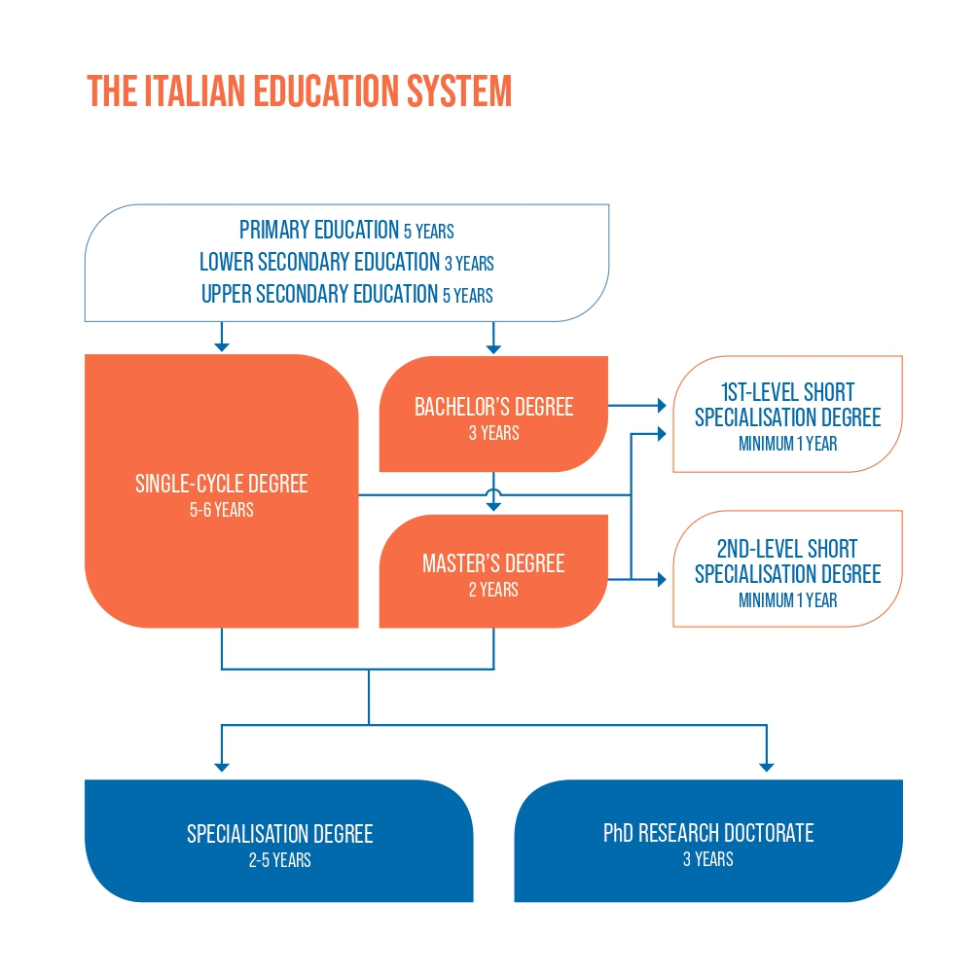
Find here more information on the Italian Higher Education system and the different opportunities offered by the University of Padua for your further studies.
- Job Placement: if you decide to start your professional career, the University of Padua provides some useful tools to approach the job market.
The Career Service of the University of Padua offers different career guidance opportunities, such as mentoring projects, job counselling, workshops also for the development of soft skills and more. We invite you to consult the dedicated website to find more information about all the projects and possibilities.
If you want to get in touch with companies or find a job, you can find more services at this page.

Check out also the Job opportunities webpage of the Department of Pharmaceutical and Pharmacological Sciences

Join our Alumni Association! The Alumni Association seeks to unite all its graduates within a community to which all may have freedom of access and equal consideration. In this way, former students — Alumni — can continue to be inspired in their professional and private lives by the fundamental values of the University, becoming standard bearers wherever they may be.

Contacts

International Desk: a dedicated department-based support desk for international students.
It provides support and guidance on the following topics:
- orientation and advising for degree programme choice;
- admission and enrolment;
- students’ welcome and access to the University services;
- support through the academic career.
To contact the International Desk send an email to:
internationaldesk.medicinachirurgia@unipd.it

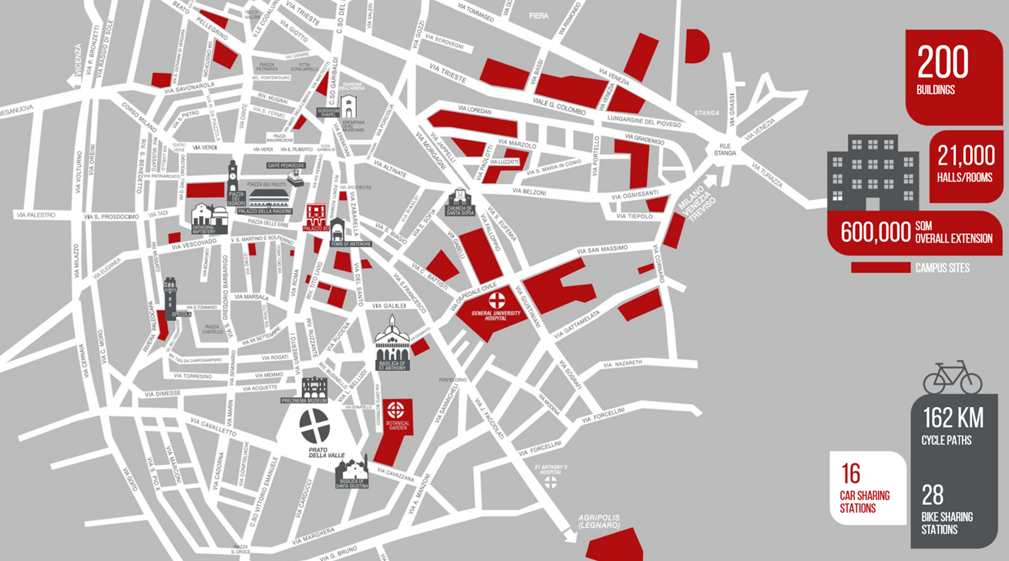
Further Contacts and Information

Health insurance information
Psychological assistance Services
Padua Tourist information
More about the University of Padova
Emergencies contacts:
Single European Emergency number 112
Medical Emergencies 118
Police/Carabinieri 112
Fire brigade 115
Follow us!

